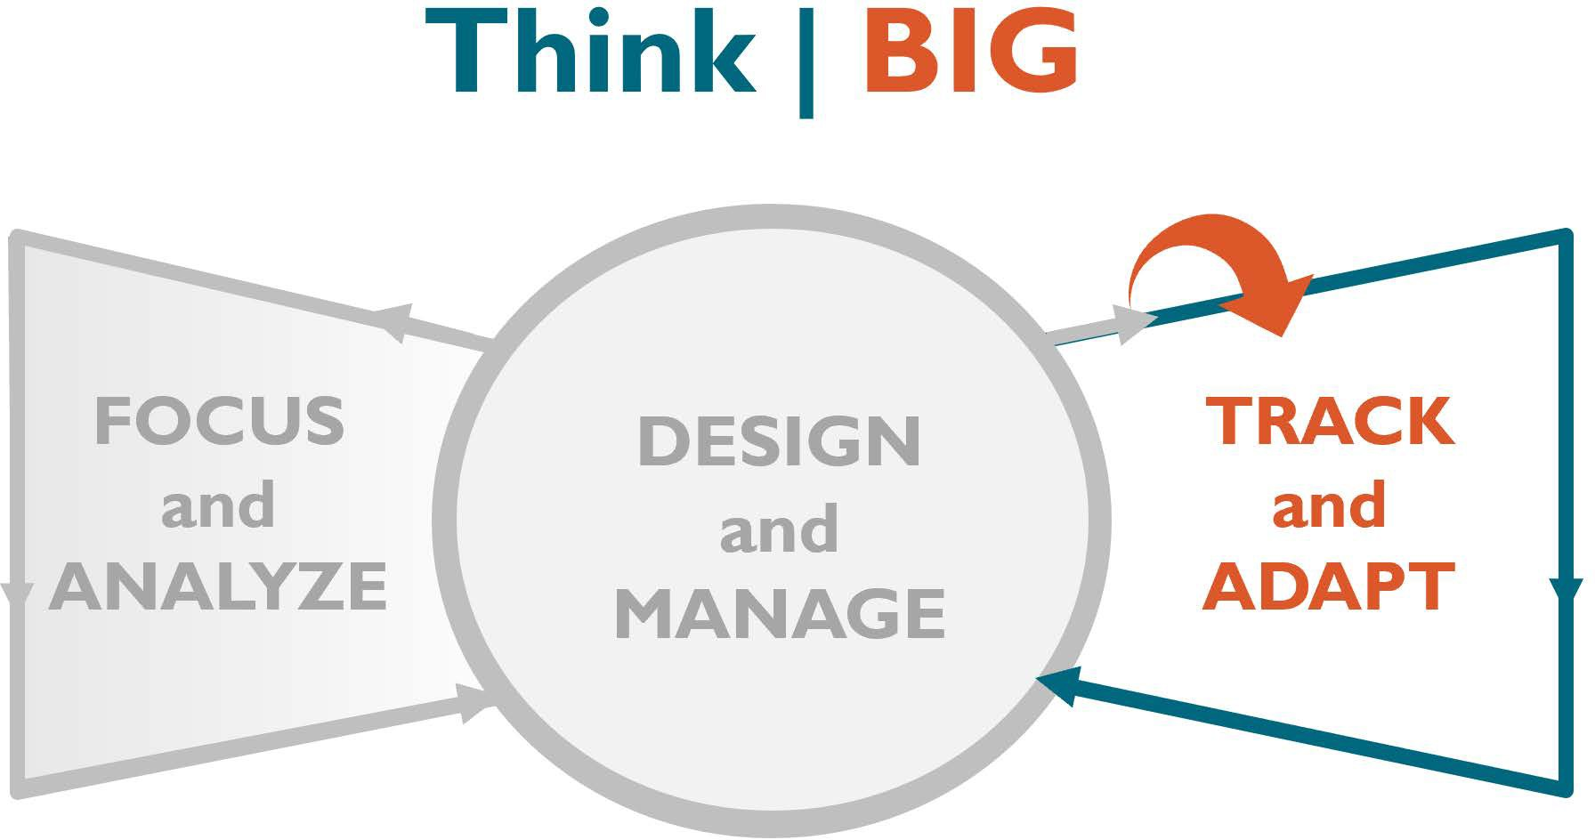
\

Behavioral and Factor-Level Indicator Assessment Worksheet

SAMPLE COMPLETED BEHAVIORAL INDICATOR ASSESSMENT WORKSHEET
BEHAVIOR OR FACTOR:
Circle or underline one
PROPOSED INDICATOR

QUESTION | YES / NO | FEEDBACK
Is the indicator properly structured?  [percentage/number/proportion of] + [who/what] + [verb (did, received, used, have access to, etc. _)] + [optional: when, where, how long, disaggregation] | YES / NO
Does the indicator capture the entire behavior or factor? | YES / NO
Is the indicator a direct measurement of the factor or behavior? | YES / NO
If the indicator is a proxy, is the assumption or rationale for it sufficient to allow its use? | YES / NO
Does the indicator (or PIRS) reflect the most appropriate specific primary actor(s)? | YES / NO
Is the behavior measured by an outcome indicator?  Note: If ‘no’ the indicator should not be accepted without changes. If you are reviewing a factor-level indicator, it does not have to be measured by an outcome indicator. | YES / NO
Is each word of the indicator unambiguous? | YES / NO
Is there an existing indicator that can be used? | YES / NO

\

General feedback and edits to the indicator for the indicator developer:
- Accept with no changes
- Accept with changes
□ Reject indicator
Reviewed by: | Date:

¹ Performance Indicator Reference Sheets (PIRS) are tools USAID uses to provide detailed definition to performance indicators, including descriptive data collection methods, rationale, and limitations.

